**The visiting exhibition** in the museum is "The Bells of Frenchay Church" and shows how parishioners and friends installed a ring of bells in Frenchay church 20 years ago.

*Frenchay Village Museum is just inside*

*Entrance "B" of Frenchay Hospital, and is open Wed., Sat., and Sun. afternoons. Admission is free*.

**The museum is closed throughout**

**December and reopens on 7th January.**

Over the last eleven years we have hosted around forty exhibitions in our Visiting Exhibition Room, ranging from a wildlife group to an amateur dramatic society. Do you know of a group interested in putting on a display in the museum's visiting exhibition room? If so …..contact Alan Freke on 0117 9570942, or email ….

[frenchaymuseum@hotmail.com](mailto:frenchaymuseum@hotmail.com) for further details.

**Frenchay Village Museum Custodians**  
 Our visitors' book shows that the museum is highly regarded by visitors, with many museum custodians reporting interesting conversations with visitors who have memories of the area to share. Sometimes they even bring in artefacts to show us.  
 We have a large team of custodians who take responsibility for manning the museum every time it's open, and they all report that every time they open up they never know who is likely to visit.   
 Recently there was a visit from three Australians, who were descended from Philip Debell Tuckett of Frenchay. They were especially delighted to visit his old wool factory at Hambrook (do you know where it is?) as they are sheep farmers from Western Australia producing wool! Some custodians were also surprised recently by a visit from Dr. Alex Moulton, of eponymous bicycle fame. Now in his 90s, he was a great friend of David Fry, and much enjoyed our Fry display, sharing many of his memories with those custodians on duty.  
 ***We are always open to more custodians joining us, so if you are interested in finding out more, no prior commitment, call Hazel Copsey on 0117 9571438.*** Whether you end up helping once or twice a month, or once of twice a year you will be equally welcome, and we're sure you will find it a fascinating experience.

**A Victorian Teenager's Diary**  
The Diaries of Mariana Tuckett were passed to us last year. Gerald and Jill Frankin have transcribed them, and they are now available on our website [**www.frenchaymuseumarchives.co.uk**](http://www.frenchaymuseumarchives.co.uk)

**Contacts**

Chairman Alan Freke 0117 9570942

Secretary Roger Angerson 0117 9569490

Treasurer Martin Longbottom 0117 9566393

Archivist Ray Bulmer 0117 9569324

Custodian Co-ordinator Hazel Copsey 0117 9571438

The Frenchay Tuckett Society

Frenchay Village Museum

Begbrook Park

Frenchay, South Glos. BS16 1SZ

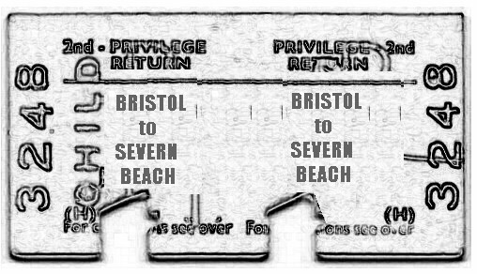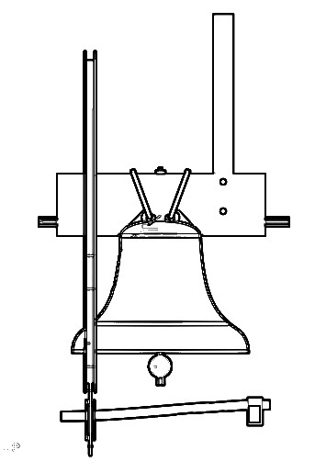

***The Frenchay Tuckett Society***

***Autumn 2011 Newsletter***

***Registered Charity No. 1066961***

[***www.frenchaymuseumarchives.co.uk***](http://www.frenchaymuseumarchives.co.uk/)

All talks are held in the

***Quaker Meeting House*** Beckspool Road, Frenchay Starting at ***7.30pm*** *Admission is £2*

**13th October 2011**

**The Bells of**

**Frenchay Church**

Alan Freke recalls how

parishioners and friends

installed a ring of bells in

the parish church 20 years

ago using bells recycled

from many sources -

Including a hospital!

*This is the Sawyer Memorial Lecture.*

**January 12th 2012**

**Day Return to Severn Beach**

David Cheesley looks back at our nearest seaside resort in the 1950s & 60s, where crowds flocked to "The Blue Lagoon" for a bracing swim.

**November 10th 2011**

**H.L.** **Packer & Co**

After so much publicity

surrounding Frys over the last

twelve months or so, John

Penny recalls Bristol's other

major chocolate manufacturer.

Packers were situated in nearby Eastville.

